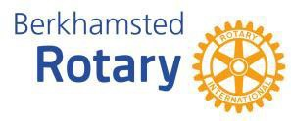
Sponsorship and Advertising 2024/25
Rotary is a humanitarian service organisation with 1.2 million members worldwide. Berkhamsted Rotary1
organises popular events that support the community and raise funds for charity.
By supporting one of our events, you can both promote your organisation in the community and contribute to some excellent causes.
In 2024/5 we’ll be putting on three main events. Why not get involved, as either a sponsor or an advertiser? See overleaf for our oﬀers.

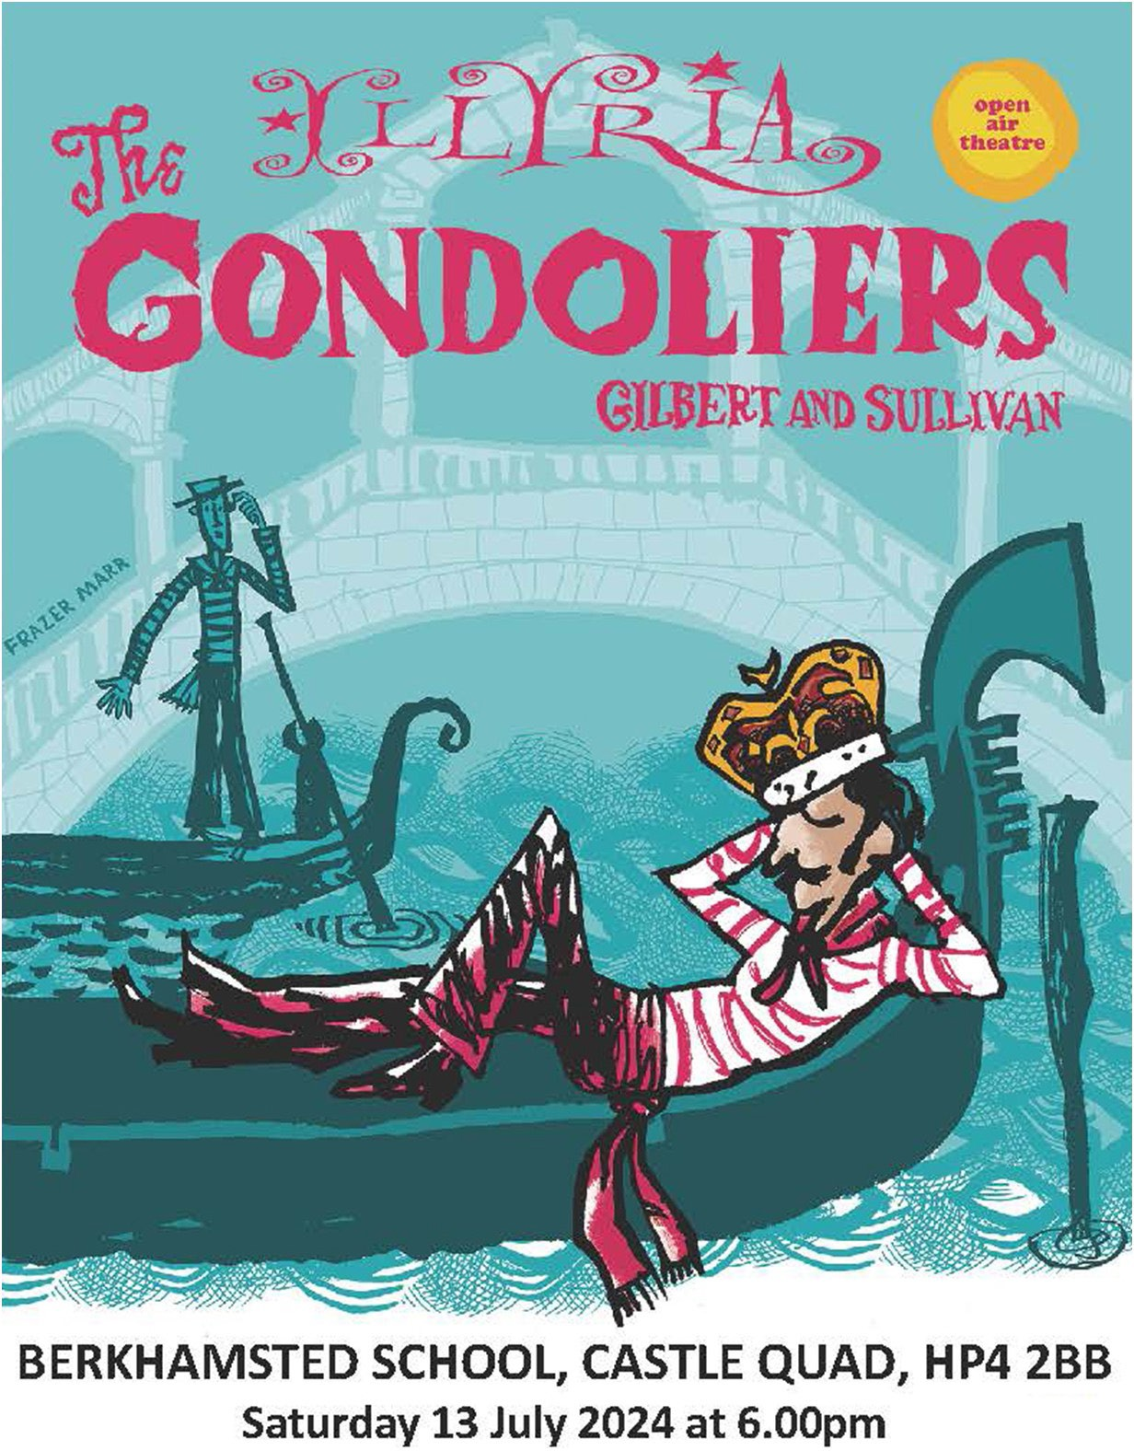
‘The Gondoliers ' Concert –13th July 2024
We will be hosting the acclaimed Illyria open air musical theatre
company returning to Berkhamsted this summer. An audience of up to 600 enjoy a picnic and then a wonderful comic opera in an atmospheric outdoor setting. Castles Estate Agents was a recent sponsor.

Fireworks November 2nd 2024
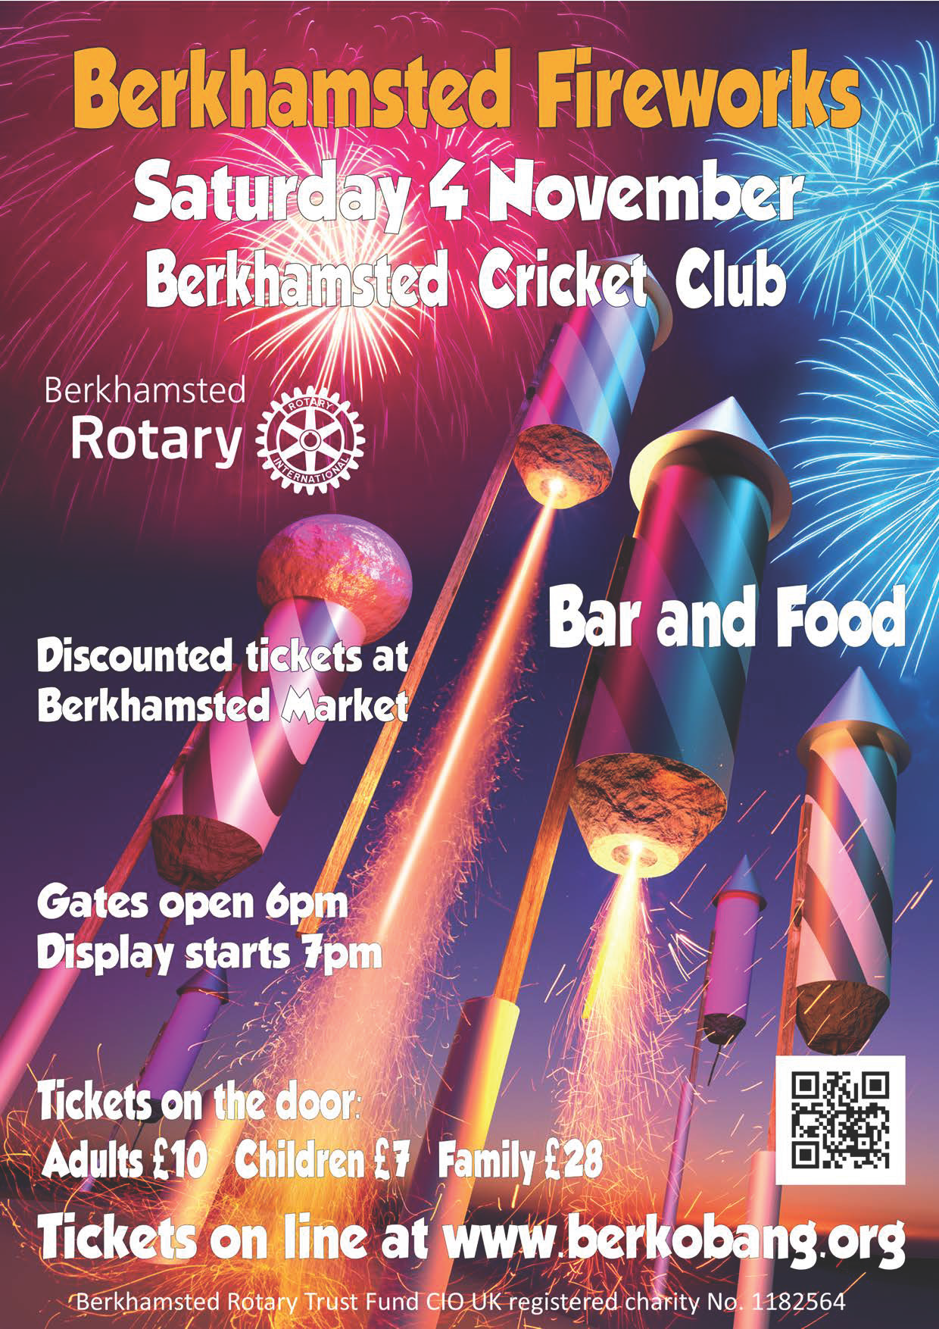
Each year we stage the premier local Fireworks display at Berkhamsted Cricket Club, drawing a crowd of up to 4000 of all ages with a top-class display, DJ and music, bar, barbecue and other attractions. SA Law was a recent sponsor.

Half Marathon & 5 Mile Fun Run 3rd March 2024
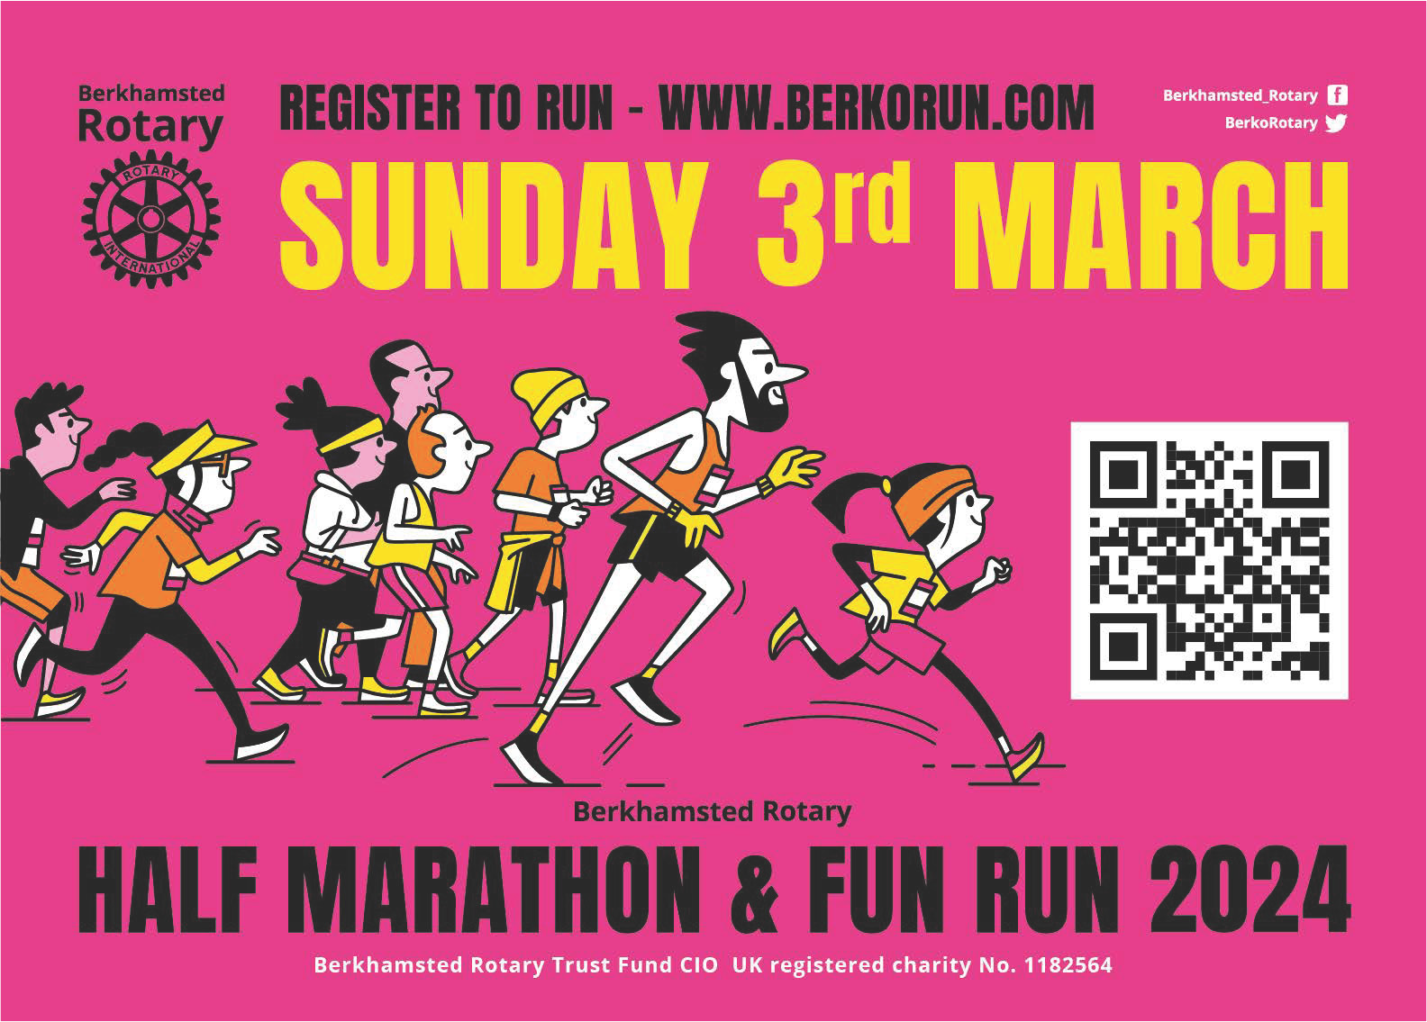
Up to 1,800 runners come from the Berkhamsted area, attracting a large crowd of spectators, especially around the start and ﬁnish at the Cricket Club. Over the years, Rotary has been able to donate more than £350,000 from this event for Hospice of St. Francis, Pepper Foundation, DENS and other charities. Current sponsors include Williams & Yates, British Gas, Machins Solicitors and Gade Valley Harriers.

1 Berkhamsted Rotary Trust Fund CIO (UK Registered Charity No: 1182564)

Promotional Offer Details
Event Promotional Packages Prices
Half Marathon & Five Mile Run | A selection from banners, social media and website, advertising literature, T-shirts, medal ribbons, water  stations, announcements, lead car, free entries and more. | Exclusive lead sponsor £7,500 Key Supporter £2,000  Associate Partner £800
 | A5 event programme will go out to every entrant and can be downloaded from the event website  (www.berkorun.com). | Advert prices range from £79 to £350
Concert in the Castle | A selection from banners, social media and website, recognition on tickets, announcements, complimentary  tickets and more. | Exclusive lead sponsor £600 Key Supporter £200  Patron £80
 | A5 event programme is free to every member of the  audience and can be downloaded from the Club website (www.berkorotary.org) | Advert prices range from £79 to £350
Fireworks | A selection from banners, social media and website, recognition on tickets, announcements, complimentary  tickets and more. | Exclusive lead sponsor £1,000 Key Supporter £350  Patron £100
 | A5 promotional fold-out leaflet has a print run of 4000, and is distributed widely in Berkhamsted. It can be downloaded from the event website  (www.berkobang.org) | Advert prices range from £190 to £320

Contact Us
To book your promotional package or find out more, please email sponsorship@berkorotary.org or phone 07947 140108.



: www.berkorotary.org https://www.facebook.com/BerkhamstedRotaryClub/ https://twitter.com/berkorotary

